Save the DATE
“Texas Run to the Wall”
Texas Vietnam War Memorial Event & Celebration!
33rd Anniversary of Honoring All Who Served
** November 6th, 2021 **

Come Friday Night (Nov. 5th), Ride to the Wall on Saturday (Nov. 6th) & Party Saturday Night, Stay at the Hotel
New BIGGER & BETTER Location for the After-Party
After-Part Now at the MCM Elegante Hotel!
… Ride & Event Schedule…
- Advanced Registration and Registration the Day of the Ride
- Ride meetup time & location to be announced.
- Ride With the Viet Nam Vets Legacy Vets MC to the Texas Vietnam War Memorial
- After-party: MCM Elegante Hotel, 2330 W. Northwest Highway, Dallas, TX
- Latest Details Available at www.TXWall.com.
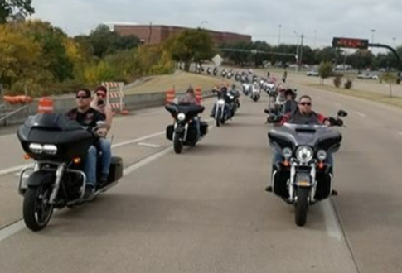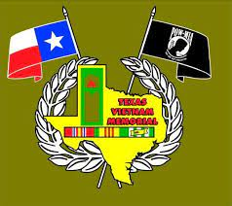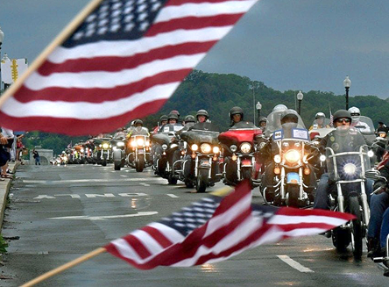
This Event Is in Honor of ALL VETERANS! After Party - Food - Music - And MORE
Event Organized by the Viet Nam Vets Legacy Vets Motorcycle Club
Points of Contacts: Colombia 817-880-1906 & Gunz: 214-250-0222

