“Texas Run to the Wall”
Texas Vietnam War Memorial Event & Celebration!
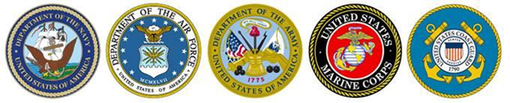
33rd Anniversary of Honoring All Who Served
** Saturday - November 6th, 2021 **
Ride Starts at Ranger Stadium (Parking Lot F)
& Proceeds to Fair Park, Texas Vietnam War Memorial – Dallas
Single $20 & Couple $25
Save with Pre-Registration On www.TXWall.com.
After-Party Is Bigger & Better This Year!
After-Party at the MCM Elegante Hotel! Stay After the Memorial Ceremony and Party with the Vets Saturday Evening (Food & Music) & Stay at the Hotel Mention “Run to the Wall” When Making Reservation for $99 Room Rate
… Ride & Event Schedule…
- Advanced Registration and Registration the Day of the Ride
- Registration Starts at 11 AM, In the Arlington Ball Park Parking lot F
- Depart at 2 PM, With the Viet Nam Vets Legacy Vets MC to the Texas Vietnam War Memorial
- Event Starts 2:30 PM, Includes Songs From the Vietnam Era, Bagpipes and Special Guest Speaker
- After-party: MCM Elegante Hotel, 2330 W. Northwest Highway, Dallas, TX
- Latest Info & Pre-Registration Available On www.TXWall.com.
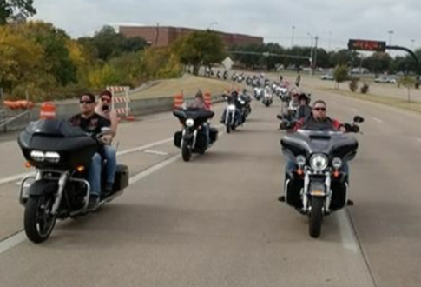 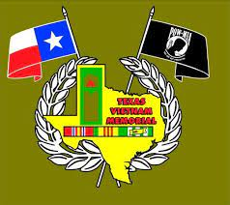 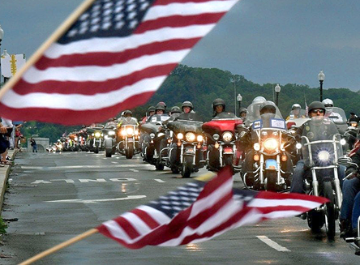
Event Organized by the Viet Nam Vets Legacy Vets Motorcycle Club
Points of Contacts: Colombia: 817-880-1906 & Gunz: 214-250-0222

